**Radioactive Decay for Barium-137 and Fiesta Plate Lab Report**

**Partner Names**

Angela Zhang

Beth Momot

**Introduction**

In this lab, both exponential and random radioactive decay were measured using a Geiger counter for both metastable Barium (Ba-137m) and uranium oxide off a Fiesta plate. For the barium, the radioactivity was analyzed by trying to find the half life, using the formula



Where I is the intensity of radiation, t is time and 𝜏 is the mean lifetime of the isotope. In the code, I₀ is represented by the dummy variable b, and (-1/𝜏) is represented by dummy variable a.

For the Fiesta plate, the results of the experiment were interpreted using a histogram and the Poisson probability mass function (pmf) which is defined as

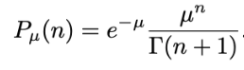

with P being the probability mass, n being the number of counts in any time interval, 𝜇 being the expected average number of counts per counting interval, and 𝛤(n+1) being the gamma function.

**Methods**

For the fast decay, we used the Barium, the exponential decay formula, and linear and nonlinear regression methods to find the half-life of the barium. For the slow decay, we used the Fiesta plates with traces of uranium oxide, the pmf, and analysis of random data to plot a histogram with Python. The choice of analyzing the faster decay with the exponential decay formula makes sense because when plotted, you can actually see the exponential decay of the barium within the time interval. It decays, as the term fast decay would suggest, quite quickly, and so the analysis of its decay using the exponential formula is a logical choice. For the slow decay, the count stays around the same value for the whole time interval of 20 minutes, because the uranium oxide decays very slowly and also occurs randomly. We assume the probability of decay is a constant, thus the choice of analyzing and interpreting the data using Gaussian or Poisson pmfs (which determines the probability of measuring a discrete random variable exactly equal to a function) makes much more sense.

**Results**

Fast Decay - Barium

Plots: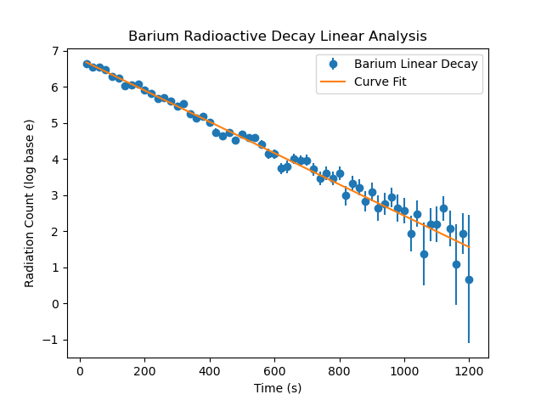

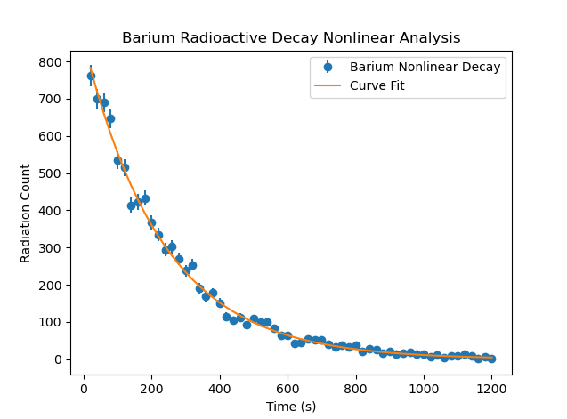

For calculating the half-lives, the following calculations were done:

Linear Regression Method:

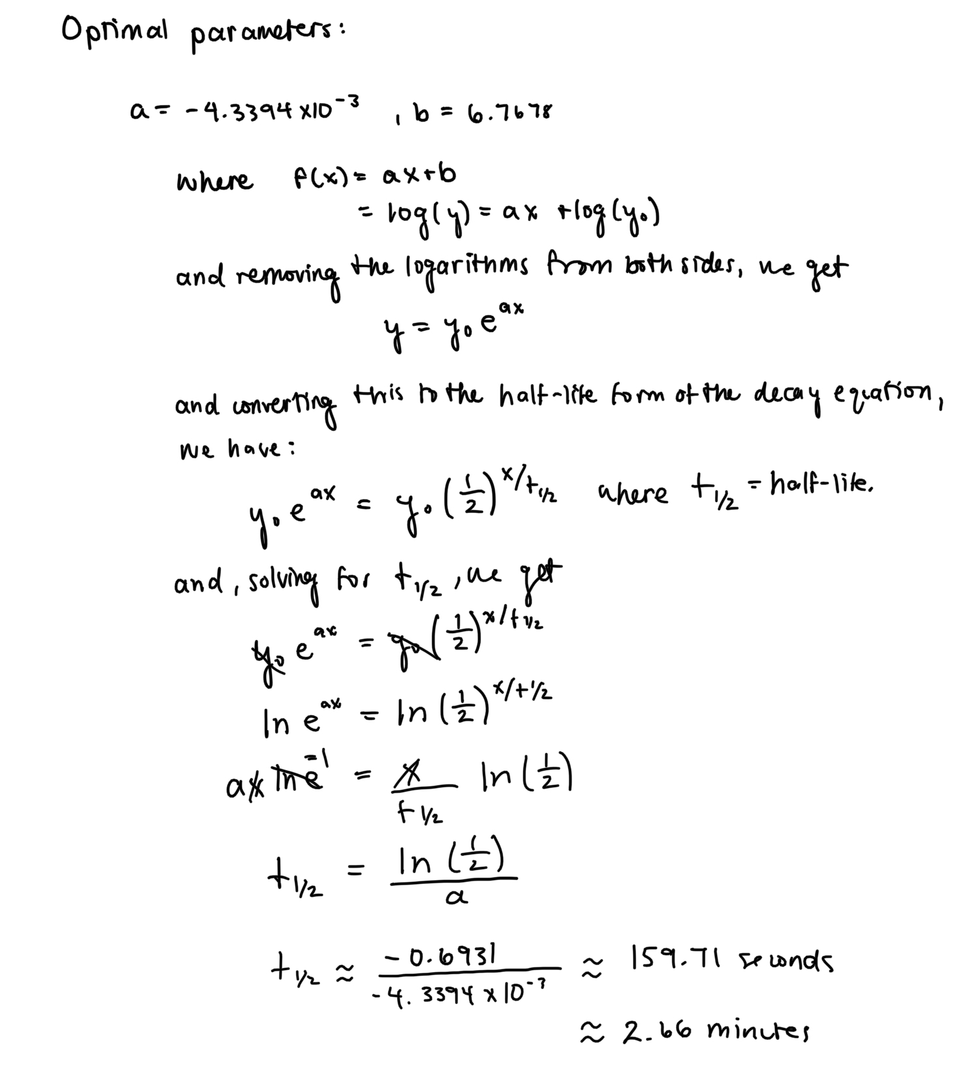

which gives a result which is quite close to the expected half-life of 2.6 minutes.

Nonlinear Regression Method:

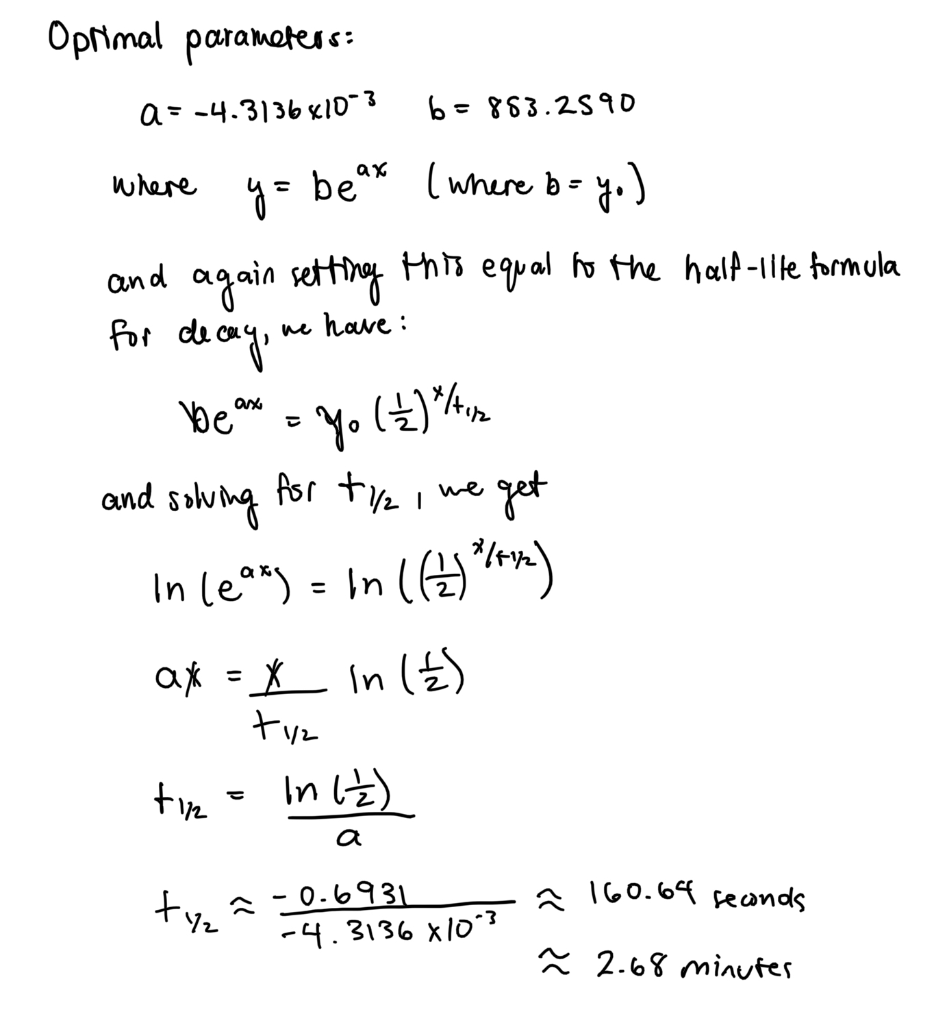

which is also quite close to the expected value of 2.6 minutes, but is a little further off than with the linear method.

Looking at both graphs and their fits, this seems at first glance to be a bit counterintuitive, given that the curve fit for the nonlinear approximation looks like a better fit than the curve fit for the linear approximation. The nonlinear fit seems to be, in general, much closer to the data points than the linear fit. But in comparing whether or not the approximations are within the ranges of uncertainties of their respective data points, they both seem to be within the range of uncertainty of most data. The goodness of the fits is thus quite comparable (as confirmed in the calculations of chi-squared), as are the values obtained for the half-lives using both methods. Where the advantage of the linear fit comes into play is that it better represents the relationship between time and radioactivity, and thus half-life. In the linear formula, they are more closely related, and will thus have an advantage for being a more accurate depiction of the half-life.

For the linear regression method, the standard deviation was calculated to be ~2.251, which is a fair value. For the nonlinear regression, the standard deviation was calculated to be ~1.782, which is an even better value. This makes sense because the nonlinear fit is more complex than the linear curve, and as previously mentioned, the curve is fitted more closely to the actual data points on the nonlinear graph. This means that there is less deviation in the nonlinear fit, even though both are comparably within most uncertainties of data points.

The value of chi-squared reduced for the linear regression approximation method was ~1.2286, which is quite good. It’s slightly above 1, but within the right order of magnitude, and not really that far off at all. The value of chi-squared reduced for the nonlinear regression approximation was ~1.2241 which is comparable to the value for the linear method, but very slightly lower, indicating a slightly better fit. But this difference is not that significant, they are quite close. By these values of chi-squared, both fits are reasonably good, and are not too well-fit, or too far off.

Given all this analysis, it seems that the equation for the nonlinear approximation of the decay of barium, and the half life being 2.68 minutes are reasonable. And it also appears that the half-life estimated by the linear method of 2.66 minutes, and the approximation equation are both good estimates as well.

As far as the estimates for the initial counts, they are both a bit off. The initial count for barium was 766, but the approximation for the initial count of barium by the linear approximation method is as follows: 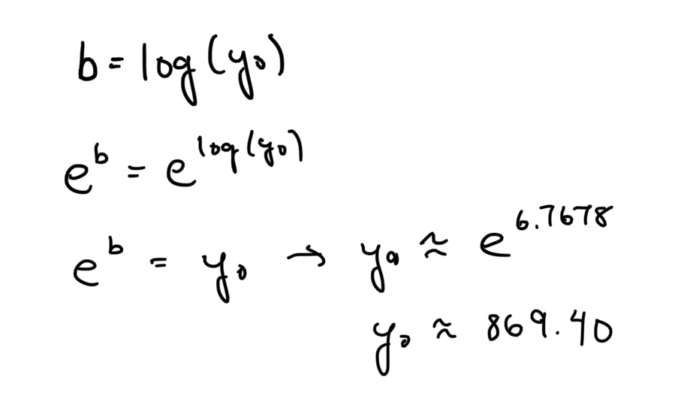

and is thus about 869, which is a pretty significant error.

The estimate for the initial count for the nonlinear approximation is simply the value given for b, which is 853. This is slightly better, but is still quite off from the actual measured value. The reason for this being off is to minimize the value of chi-squared. The code prioritizes finding the minimum possible chi squared value over having the initial value be exactly right.

Slow Decay - Fiesta Plate (Uranium)

Plots: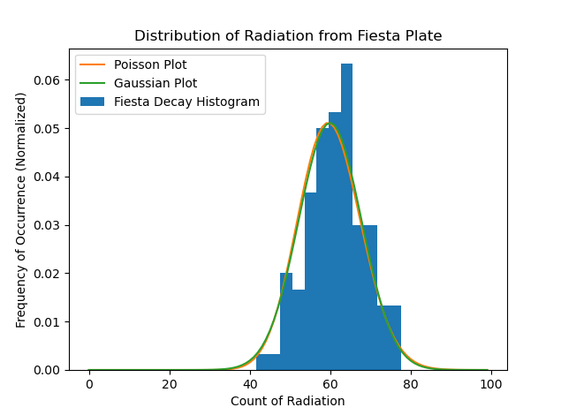

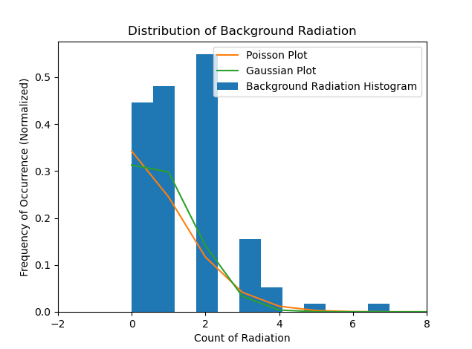

For the histogram of the radiation from the fiesta plate, we see that there is almost no difference between the Gaussian function and the Poisson function. This confirms that there are indeed enough data points in this distribution for them to look the same. For the background data only histogram, the Gaussian and the Poisson functions on the plot are more detectably different. But they are still similar, with the main difference being from the differences within the range of radiation count from 0 to 2. There are 100 data points for both of these plots so the reason why the Gaussian is different for the solely background radiation plot must not be because there aren’t enough data points. The difficulty in having both the Gaussian and the Poisson functions be the same for the background data is likely because of the odd shape of that histogram. Rather than being somewhat symmetrical (as the histogram for the total radiation of the fiesta plate is), it is rather lopsided, not having any values below zero. This oddity is likely what is making it difficult to get a more accurate fit between the Gaussian and Poisson. It is not at all symmetrical on either side of the mean of 1.43, and has a far greater deviation to the right (for values greater than the mean).

To build upon what was mentioned in the methods section, about why a histogram was chosen to analyze this slow form of decay, it is clear from the histogram that this data would not be well-suited for analyzing the half-life. The mean for the sample radiation data was determined to be 60.96, with the data being evenly (though not completely symmetrically) distributed on either side of this value. This means that, while there was some deviation from the ‘initial value’ (which is not a useful term to analyze in this case), there was no pattern in the data trending linearly or exponentially downwards. It is rather better to analyze what value the count hovers around, and how the count deviates from that value of around 60 throughout the measurements. While the uranium is decaying, and is doing so exponentially, it is doing so extremely slowly, so slowly that its decay is undetectable in the 20 minute time interval during which we measured the count.

**Conclusions**

In conclusion, the fits for the exponential decay of Barium seem to work quite well. The standard deviations are quite reasonable and the values of chi-squared are both around the desired value of 1. The half-lives calculated using both the linear and nonlinear methods were both quite close to the expected value as well, which is another indicator of good fits. Both fits made sacrifices on the accuracy of the initial count estimate in order to make the fits more accurate.

For the Fiesta Plates, the histogram of the sample data seems to be quite appropriate, though not quite symmetrical. There were enough data points for the Gaussian and the Poisson functions to look essentially the same. The histogram of just the background data is a bit wonky, and not at all symmetrical nor is it evenly distributed on both sides of the mean. This asymmetry is likely what causes the difference in the Poisson and Gaussian functions’ appearances.